Opening a REQ

Objective
Opening a REQ via ServiceNow and ServicePortal

Responsibility Definition
Any employee can open a request via ServicePortal.
- Only IT analysts can open requests via ServiceNow.

Step by Step – ServicePortal
- When accessing the Contoso intranet (Contoso Intranet | Home)
- Click on “My Essentials” and then on “ServiceNow”.
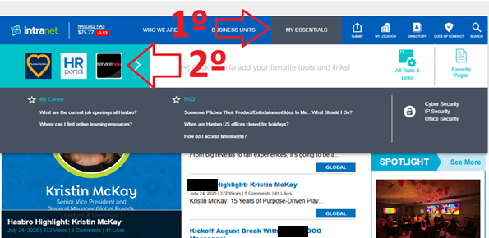
- On the next screen, click on “System Access”:
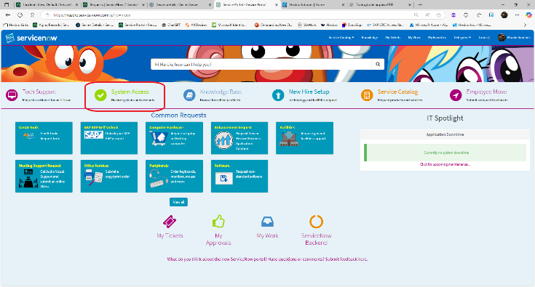
- On the “System Access” screen:
- Select who you are requesting access for.
- Select a user as a template — someone who already has the program.
- Select from the list the Software you need access to. This list covers only standard software, i.e., software that Contoso already has in its file bank in Software Center.
- Click “Next”.
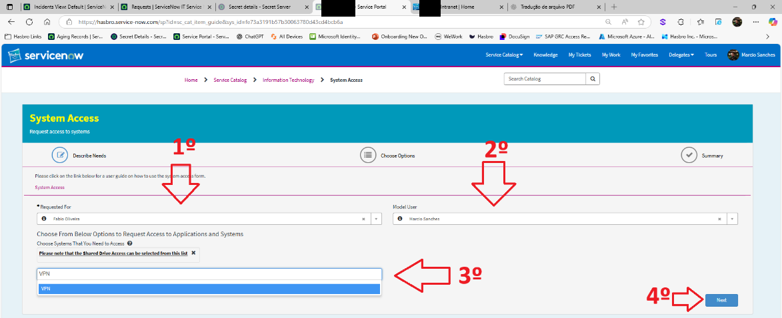
- On the next screen, fill in the “Options” form if necessary.
- Then click “Submit”
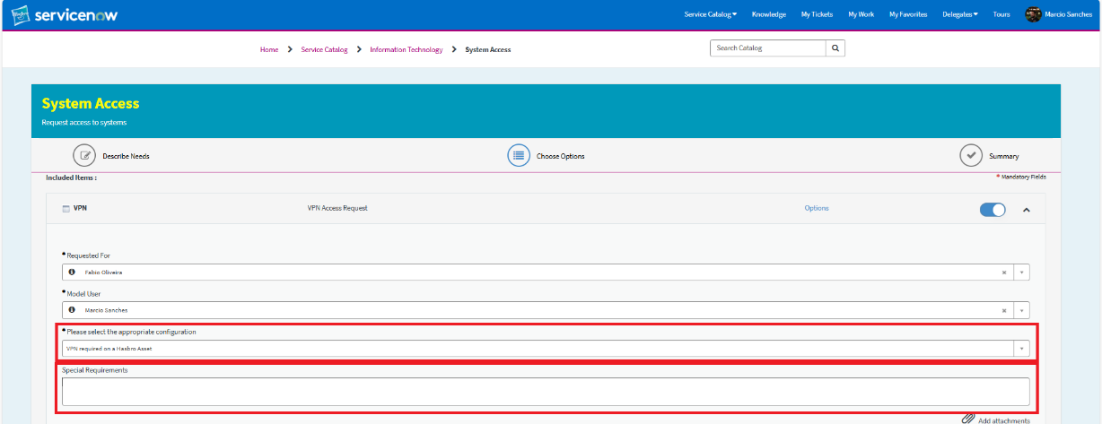
NOTE: Each software has a different “Options” form.
- The REQ details will then appear with the access request information: REQ number, approval chain, and execution:
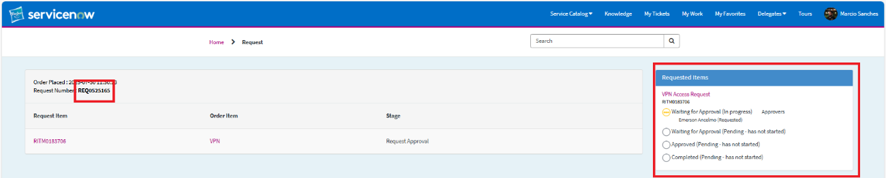

Step by Step – ServiceNow
- Access the ServiceNow site (Tickets and Incidents | ServiceNow). Click on the Requests list on the left and the “New” button on the right:
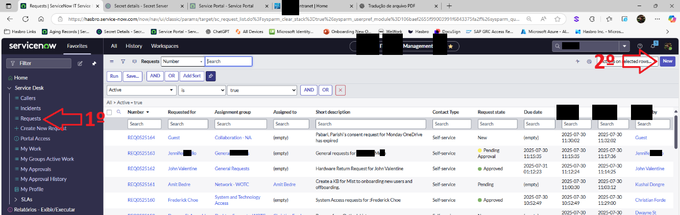
- On the next screen, fill in all the options:
“Requested For”: The employee who needs support
“Configuration Item”: Software the user needs support for
“Priority”: REQ ticket priority is ALWAYS “Priority 3”. This never changes.
“Contact Type”: ALWAYS keep it as “E-Mail”.
“Assignment Group”: Select which department can handle the request.
“Assignment to”: If the Assignment Group is “Service Desk (BR) - LAM”, select your name from the list.
In the “Short Description” and “Description” fields, provide a brief description in the first field and the full request description in the second. Always in English.
Finally, click “Submit”.
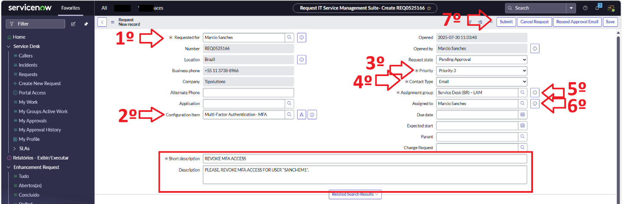

Version History
Author | Version | Date | Change Description
IT Team | 1.0 | 30/07/2025 | Creation
Lucas Souza | 1.1 | Jun/2026 | Document standardization

